# THIS DOC IS TEMPORARY, BUT LOOK AT THIS GIRAFFE, PEOPLE!

This is a temporary document, and here is a picture of a giraffe:

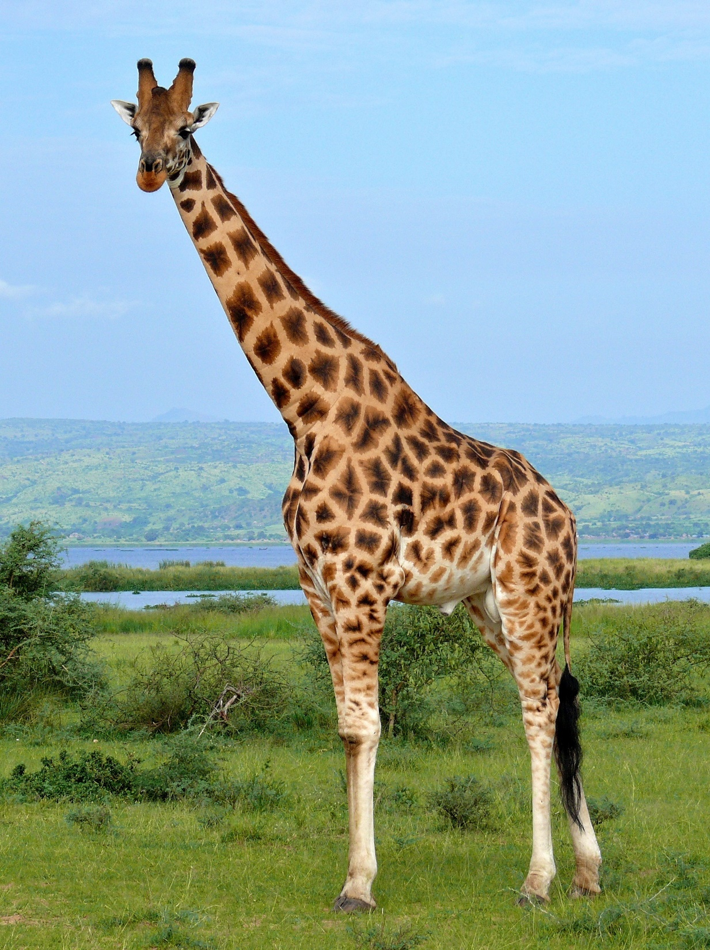

# I think my formatting may be getting a little bit out of hand, but…

Here’s another page.

Pretty soon, this will also be a PDF.

Isn’t that wonderful?

Baloney sandwich